FIRST ANNOUNCEMENT
第２回国際SATヘルスカウンセリング会議

The 2nd INTERNATIONAL CONFERRECE OF SAT HEALTH CONFERRENCE

SAT Enhancing Resilience

2010
第2回国際ヘルスカウンセリング会議（第1回アナウンスメント）

メインテーマ SATで高めるレジリエンス

会期：2010年9月18日（土） 18：30開始予定
会場：市川市文化会館
主催：NPO法人ヘルスカウンセリング学会
INTERNATIONAL SAT ASSOCIATION

スケジュール

発表エントリー締め切り 2010年7月15日（木）
発表要旨提出期限 2010年8月5日（木）
プロシーディング英文論文提出 2010年10月31日（日）

第２回国際SATヘルスカウンセリング会議では、SATに関する臨床・実践研究を広く募集しております。多くの方の、ご参加を心からお待ち申し上げます。

ORGANIZATION
Organizer Organizing Committee of the 2nd International Conference of
SAT Health Counseling

Co-sponsors ACADEMY FOR HEALTH COUNSELING
INTERNATIONAL SAT ASSOCIATION

Conference Theme SAT Enhancing Resilience

Organizing Committee

Chair Munakata, Tsunetsugu President, Academy for Health Counseling
President, International SAT Association
Chair, Department of Human Care Science
University of Tsukuba

Secretary-General Associate Secretary-Generals
Hashimoto, Sayuri Higuchi, Noriko;
Hu Wenyan
Francis Onuoha

SECRETARIAT: ORGANIZING COMMITTEE OF THE 2nd international Conference of SAT Health Counseling, MEIKAI UNIVERSITY ,1701, Faculty of Languages and Cultures Department of English、Noriko Higuchi
Akemi 1, Urayasu, Chiba, JAPAN 279-8550
Phone: 81-47-355-5120 FAX: 81-47-350-5504

会議事務局：第2回国際SATヘルスカウンセリング会議事務局
明海大学外国語学部英米学科 樋口倫子
〒279-8550
千葉県浦安市明海１ 管理研究棟1701 明海大学外国語学部英米学科 樋口倫子
TEL: 047-355-5120（教員代表）FAX: 047-350-5504（教員代表）
E-Mail：nhiguchi@meikai.ac.jp

From the Chair 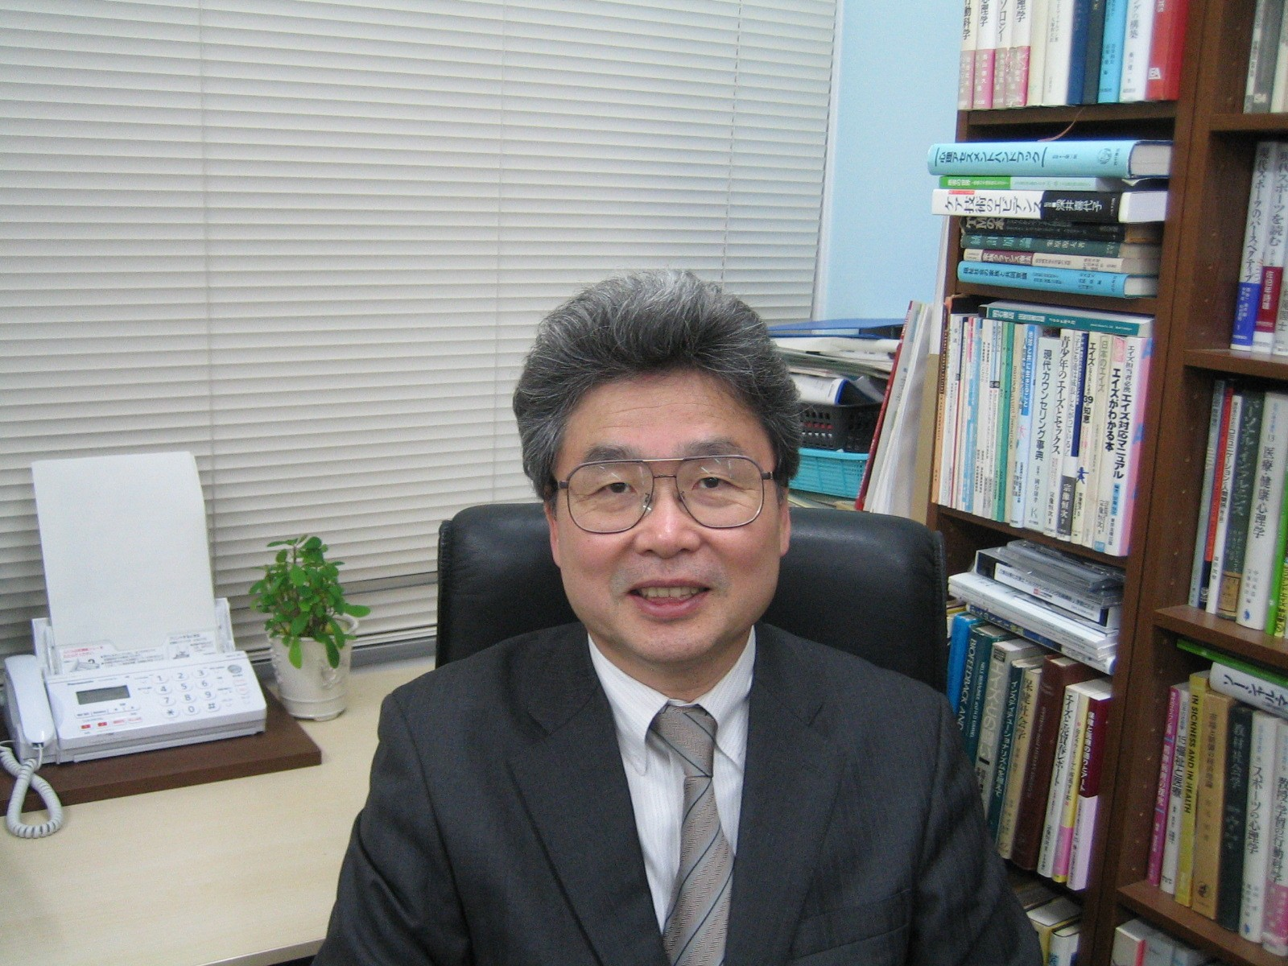

The 2nd INTERNATIONAL CONFERRECE OF SAT HEALTH CONFERRENCE

We hereby sincerely invite you and other representatives from your organization to join the 2nd international conference of SAT health counseling, September 18, Saturday, 2010 in Chiba, Japan.
The 2nd international conference of SAT health counseling highlights “SAT Enhancing Resilience” . We hope to develop this conference into an international academic society for probing SAT counseling & therapy as the 3rd advanced generation of CBT and as a research and global educational method by designing effective training and remedial intervention programs in SAT Method. Especially, we are expecting to discuss about SAT Method leading global strategies in the future for successful performance, stress management, mental health maintenance, innovation in health care technology, chronic disease or lifestyle-related disease management and health behavior change. We believe this conference will be of great benefit to our future cooperation on developing the effective program to improve human’s well-being.
We are all looking forward to seeing you soon, and should you have any questions, please feel free to inform me.

Professor Tsunetsugu Munakata, Dr H Sc
Advanced Research Building D511,
1-1-1 Tennoudai, Tsukuba, JAPAN 305-8577
Phone＆Fax: 81-29-853-3971
E-mail：munakata@hcs.tsukuba.ac.jp
http://www.hcs.tsukuba.ac.jp/~munakata/

Chaiｒ，Organizing Committee of
the ２nd International Conference of
SAT Health Counseling
Chair, Department of Human Care Science
School of Comprehensive Human Sciences
UNIVERSITY OF TSUKUBA

CONFERENCE INFORMATION
VENUE

Ichikawa City Cultural Hall

〒272-0025 千葉県市川市大和田1-1-5

TEL:047-379-5111

DATE
INTERNATIONAL CONFERENCE: 18:30－21：00 , SEPTEMBER 18(SAT), 2010
JAPAN NATIONAL MEETING OF ACADEMY FOR HEALTH COUNSELING: SEPTEMBER 18 (SAT.) 9:50-18:00, SEPTEMBER 19 (SUN.) 9:30-17:00

LANGUAGE
English shall be the official language for the conference

REGISTRATION DESK
The registration desk is open as follow:
September18 (SAT.) 9:50-18:00
September19 (SUN.) 9:30-17:00
WELCOME PARTY
Data: Satday,18 September, 2010
Time: 17:40-18:30
Fee: 2,000 yen (Free for Invited Guests)
Venue: Ichikawa City Hall

ON SITE REGISTRATION OF THE INTERNATIONAL CONFERENCE
The registration desk will be provided at the conference site and will be open throughout the conference period. Those who intend to register during the conference period are requested to pay the registration membership 1000 in Japanese Yen for participating in the International Conference at the registration desk in cash only.

SECRETARIAT: ORGANIZING COMMITTEE OF THE 2nd international Conference of SAT Health Counseling,
MEIKAI UNIVERSITY,1701,Faculty of Languages and Cultures Department of English
Noriko Higuchi
Akemi 1, Urayasu, Chiba, JAPAN 279-8550
Phone: 81-47-355-5120 FAX: 81-47-350-5504

会議事務局：第2回国際SATヘルスカウンセリング会議事務局
明海大学外国語学部英米学科 樋口倫子
〒279-8550
千葉県浦安市明海１ 管理研究棟1701 明海大学外国語学部英米学科 樋口倫子
TEL: 047-355-5120（教員代表）FAX: 047-350-5504（教員代表）
E-Mail：nhiguchi@meikai.ac.jp

SUBMISSION FORM 参加申請書
発表申込締切：2010年7月15日
発表要旨締切：2010年8月5日

Corresponding author(s). This author is responsible for communicating information about the submission to co-author(s), if any. 責任申請者

Name: 氏名

Institution: 所属先

Address: 連絡先住所

Country: 国名

Tel: Fax: E-Mail

SUBMISSION TITLE: 発表題目

送付先
SECRETARIAT: ORGANIZING COMMITTEE OF THE 2nd international Conference of SAT Health Counseling, MEIKAI UNIVERSITY,1701,Faculty of Languages and Cultures Department of English Noriko Higuchi Akemi 1, Urayasu, Chiba, JAPAN 279-8550
Phone: 81-47-355-5120 FAX: 81-47-350-5504

会議事務局：第2回国際SATヘルスカウンセリング会議事務局
明海大学外国語学部英米学科 樋口倫子
〒279-8550千葉県浦安市明海１ 管理研究棟1701 明海大学外国語学部英米学科 樋口倫子
TEL: 047-355-5120（教員代表）FAX: 047-350-5504（教員代表）
E-Mail：nhiguchi@meikai.ac.jp
SUBMISSION INSTRUCTIONS

The author-prepared abstract will be published exactly as presented on original.
Type must be clear, dark and correct. DO not reduce or condense. All abstracts will be reduced for publication. Plain paper may be used in place of ‘Abstract Form’, provided exact dimensions (12.7cm×18cm) are maintained.
Papers which cluster around common themes may be selected for group oral presentation, each about 15 minutes. ALL papers should be submitted under the ’ paper or poster’ option.

TO SUBMIT A PAPER PROPOSAL
- Complete the Submission Form.
The form must be received by July 15, 2010.
- Prepare an Abstract to fit within the Abstract Form.
- Provide a concise description of your proposed presentation in narrative from. Include author(s) name(s), affiliation, and the corresponding author(s) name and address.
- Copy all Form/Information for your reference. Retain Abstract on disc for future use.
- Abstract submissions must be received by Aug 5, 2010.
- Full paper must be received for the conference proceedings by Oct 31, 2010
発表要旨の提出は、2010年８月5日が締め切りです

ABSTRACTS SHOULD:
- State the scientific question or purpose of the study;
- Characterize the study sample (sample size, age, gender, race, health status, etc);
- Identify the independent and dependent measures, types or specific names of measures used;
- Summarize analysis, and describe key results;
- State conclusions and/or significance of findings
SECRETARIAT: ORGANIZING COMMITTEE OF THE 2nd international Conference of SAT Health Counseling, MEIKAI UNIVERSITY,1701, Faculty of Languages and Cultures Department of English Noriko Higuchi
Akemi 1, Urayasu, Chiba, JAPAN 279-8550
Phone: 81-47-355-5120 FAX: 81-47-350-5504
会議事務局：第2回国際SATヘルスカウンセリング会議事務局
明海大学外国語学部英米学科 樋口倫子
〒279-8550千葉県浦安市明海１ 管理研究棟1701 明海大学外国語学部英米学科 樋口倫子
TEL: 047-355-5120（教員代表）FAX: 047-350-5504（教員代表）
E-Mail：nhiguchi@meikai.ac.jp
The 2nd INTERNATIONAL CONFERENCE OF SAT HEALTH COUNSELING
ABSTRACT FORM 発表要旨
＊Abstracts may be submitted on this form (or on plain paper within 12.7cm×18cm dimension)
Abstract submissions must be received by AUG 5, 2010
発表要旨の提出は、2010年8月5日が締め切りです。

(Title) 題目

(Name) 発表者氏名, (Affiliations) 所属先

(Purpose) 目的

(Method) 方法

(Result and Discussion) 結果と考察

(Concussion) 結論

ALL papers should be submitted under the ’ paper or poster’ option.
Circle your option, １． Oral ２． Poster 3. No Preference
OFFICE USE
Reg. ♯………………………Date received……………………….Abs.♯……………………….

Access to Ichikawa City Cultural Hall

市川市文化会館

〒272-0025 千葉県市川市大和田1-1-5

TEL:047-379-5111
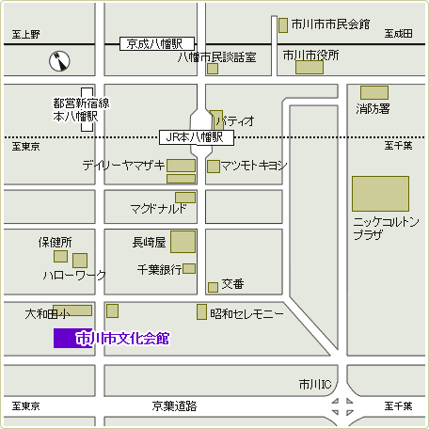

JR線

総武線本八幡駅南口より徒歩10分

私鉄

京成線八幡駅より徒歩15分

地下鉄

都営新宿線本八幡駅A3出口より徒歩10分

バス

行徳方面からお越しの方は、本八幡駅行のバス「文化会館前」下車

車

京葉道路ご利用の方は市川インター下車

※当館の駐車場は主催者専用となっておりますため、お車でのご来館はご遠慮ください。

